***Task 11 – Exception Handling***

Q1. Types of access modifiers in Java and their significance in class, method and variable accessibility:

Access modifiers in Java specifies the accessibility or scope of a filed, variable, method, constructor and class. There are 4 access modifiers in Java

1. **Public**:
   1. Accessibility of public is everywhere. It can be accessed from within the class, outside the class, within the package and outside the package
   2. Variables, methods and class specified as Public can be accessed from anywhere
2. **Private**:
   1. Access level of private is only within the same class. It cannot be accessed from outside the class
   2. Variables, methods can be accessed only within the class
3. **Default**:
   1. When no modifier is specified, it will be default. The access level of default modifier is only within the package, it cannot be accessed from outside the package
   2. Variables, methods and class specified default can be accessed only within the package.
4. **Protected**:
   1. Accessibility of protected modifier is within the same package and can be accessed by sub classes in different packages. It cannot be accessed by non-sub classes outside the same package
   2. Variables, methods and class can be accessed within same package and by sub-classes outside the package.

|  |  |  |  |  |  |
| --- | --- | --- | --- | --- | --- |
| Access  🡪    Modifier | Same class | Same package | Outside class | Outside package sub class | Outside package non sub class |
| Public | Yes | Yes | Yes | Yes | Yes |
| Private | Yes | No | No | No | No |
| Protected | Yes | Yes | Yes | Yes | No |
| Default | Yes | Yes | Yes | No | No |

Q2. Difference between Exception and Error:

|  |  |
| --- | --- |
| **Exception** | **Error** |
| Exceptions can be handled | Errors cannot be handled |
| Exceptions in Java can either be checked or unchecked | All errors in java are unchecked |
| Exceptions occurs due to the code | Errors arise due to lack of system resources |
| Exception occurs at run time. Checked exceptions can occur at compile time | Errors occur at compile and run time |
| Types: Checked and Unchecked Exceptions | Types: Syntax, Runtime and logical errors |
| Exception has the ability to change the flow of the execution/program | Error has the ability to terminate the code/execution |
| Exceptions are defined in java.lang.Exception package | Errors are defined in java.lang.Error package |

Q3. Difference between Checked and Unchecked exceptions:

|  |  |
| --- | --- |
| **Checked Exception** | **Unchecked Exception** |
| Checked exceptions occurs at the compile time | Unchecked exceptions occur at the runtime |
| The compiler checks these exception | These exceptions are not checked by the compiler |
| Checked Exceptions are the sub-class of Exception | Unchecked Exceptions are not sub-class of Exception |
| Checked exceptions can be handled at the compile time | Unchecked exceptions cannot be handled at compile time |
| JVM needs the exception to be handled using Try and Catch | JVM doesn’t need the these exception to be handled |
| Examples : FileNotFound  ClassNotFound | Example : ArithmeticException  ArrayIndexOutOfBound |
|  |  |

Q4. Program to handle exception

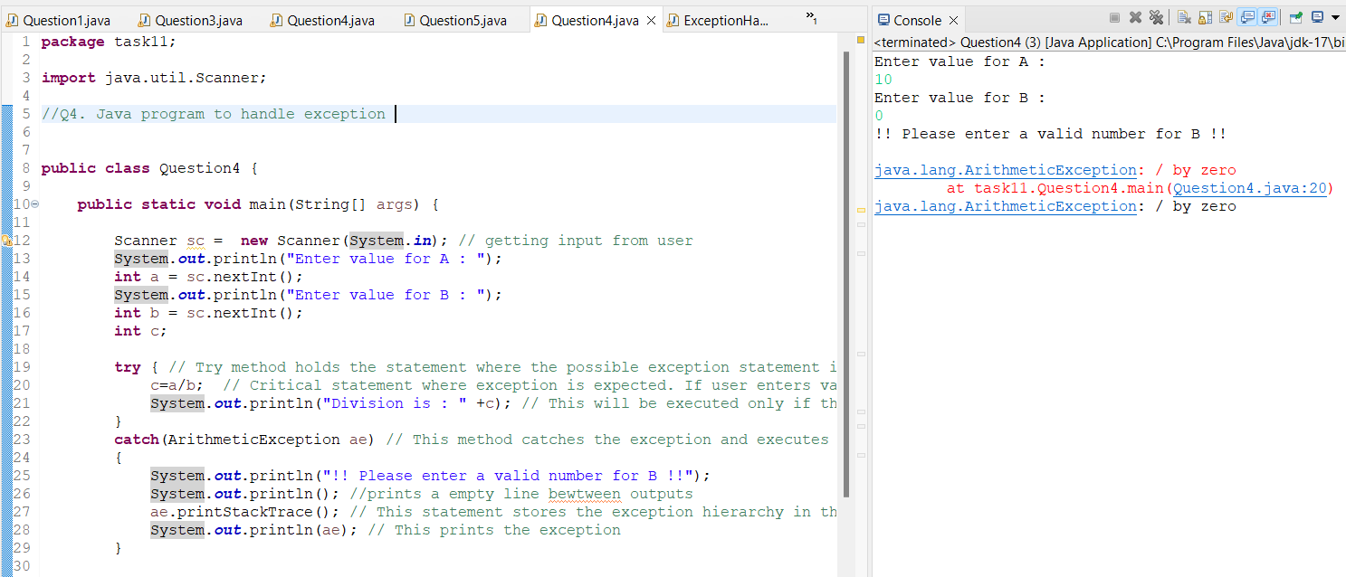

Q4. Output

Q5. Array and string out of bound Exception

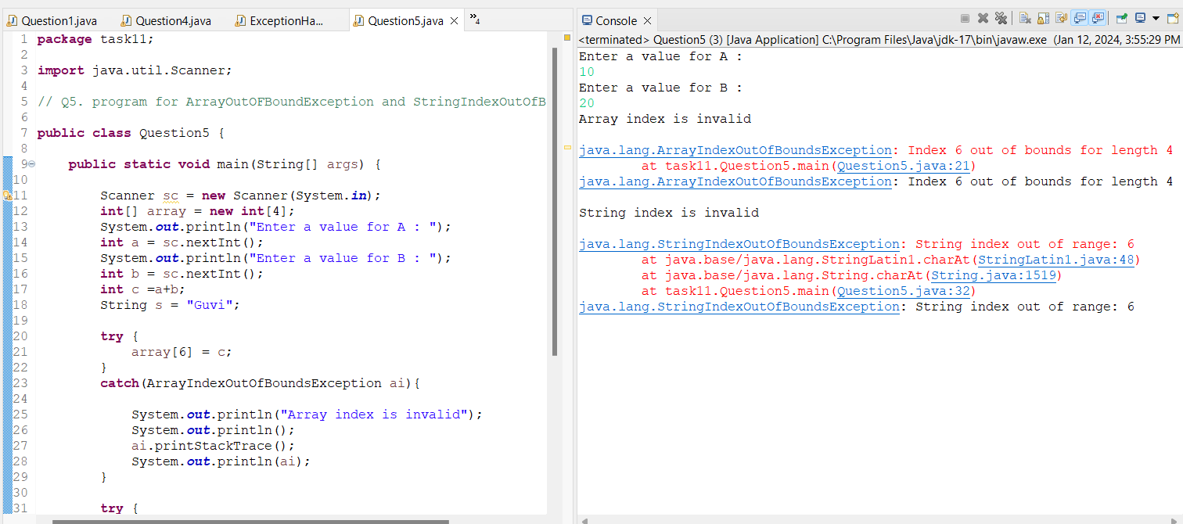Q5 Output

Q6. Login function exception with user defined exception

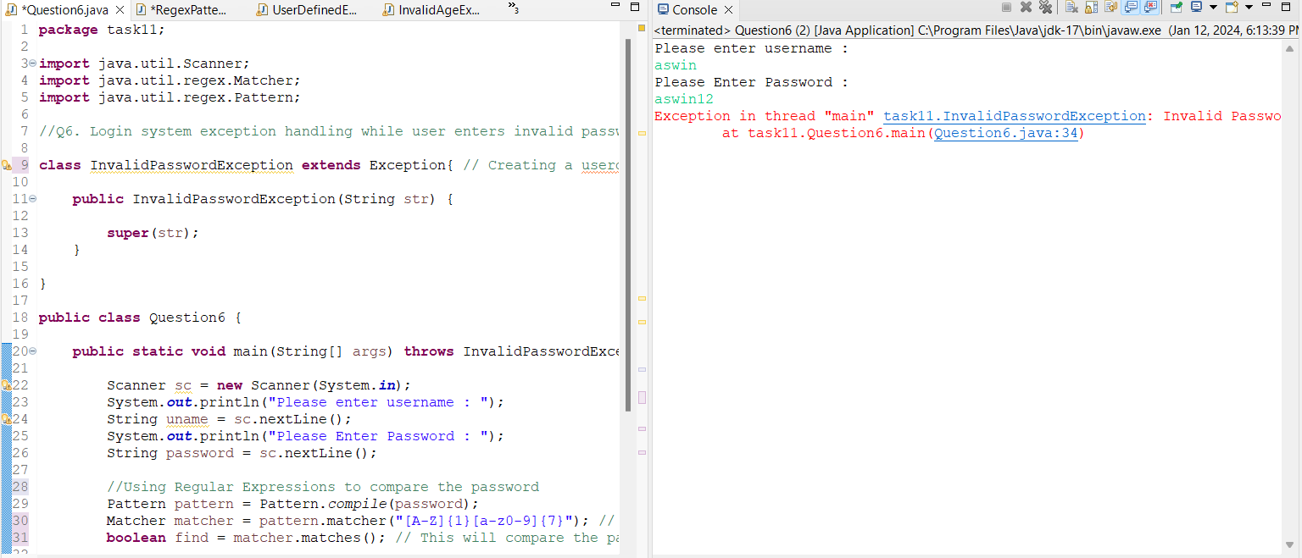

Q6.1 : This screenshot shows how exception is thrown using user defined exception

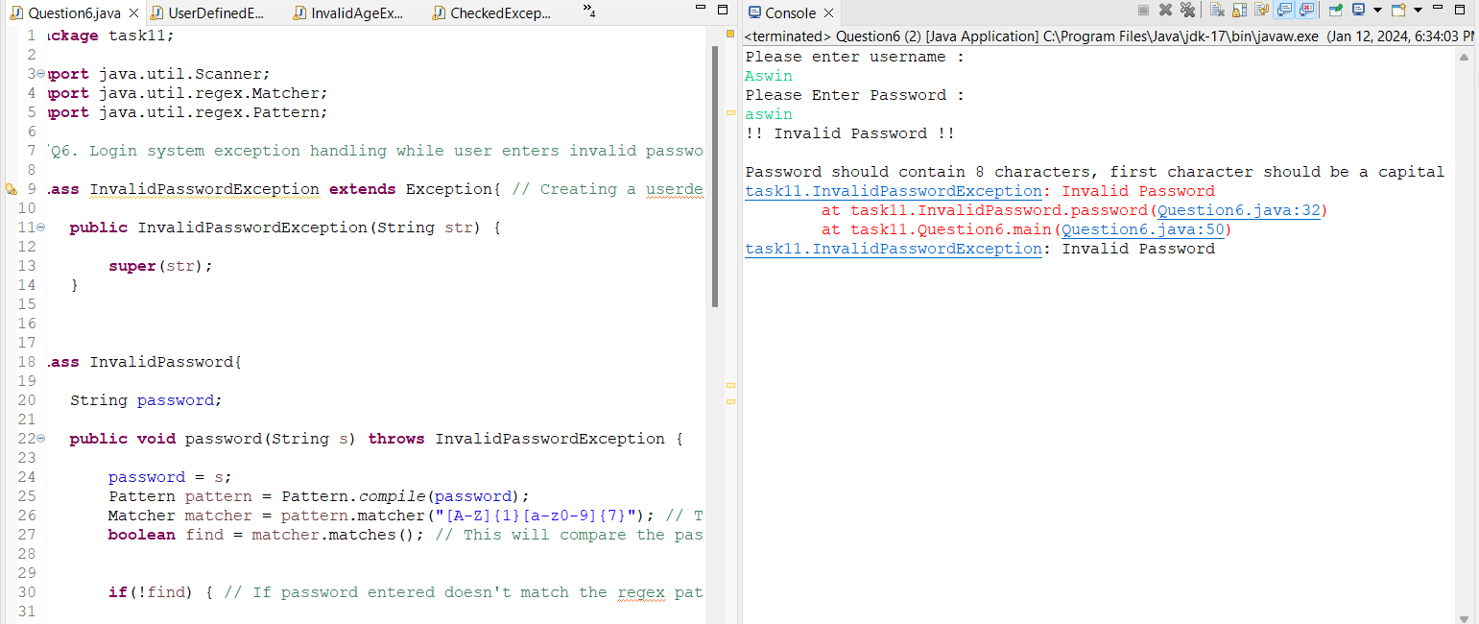

Q6.2 This screen shot shows the handling of the exception

Q7. Program for Invalid Age Exception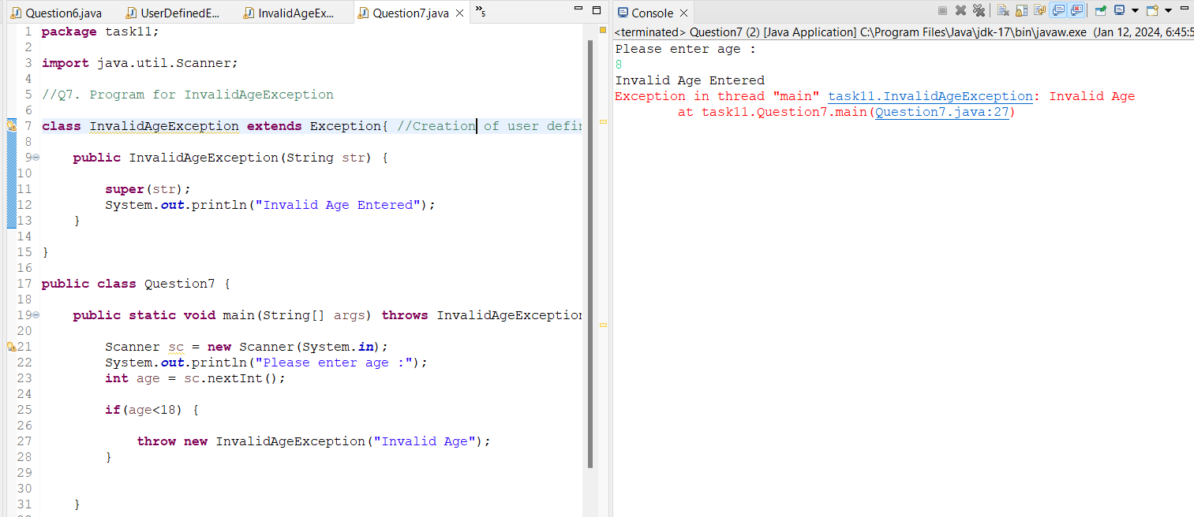

Q8. FileNotFoundException

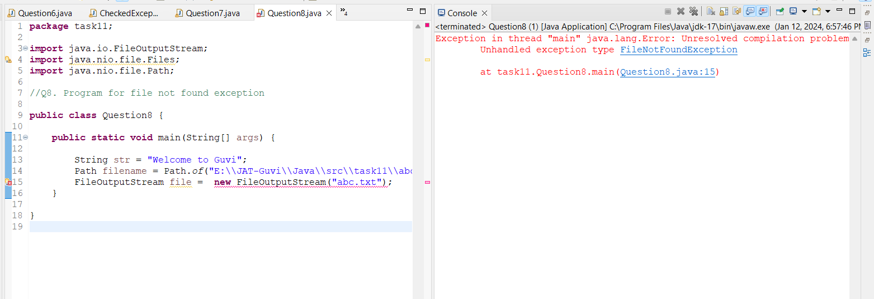

This screenshot shows that FileNotFoundException output